College Bank And Lower Falinge Mesh Proposal

# The Overview

We have been asked to look into the feasability of creating civic accesss to internet services using a wifi mesh topology.

This is acheivable, with certain caviats:

* An Internet Service Provider who can provide enough bandwidth to cover edge devices and services;
* Maintaining/managing the access control via firewall etc.
* Connectivity at the edges of the physical locations.

We suggest rolling out from College Bank, with Internet Gateway there (possibly Holland Rise Concierge room) and build the mesh network to remaining blocks from there. (fig 1.)

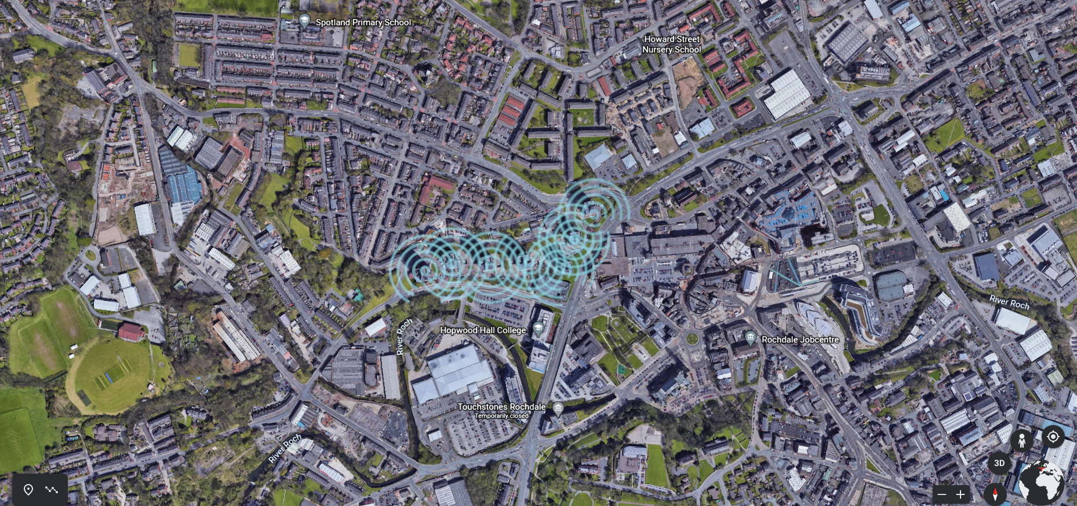Figure 1: Fig 1.

We propose that wifi ssids are broadcast from each block, and due to the physical structures and materials, the block opposite woud be strongest connection signal.

Most blocks are less than 40 metres apart, with the exception of Underwood to Town Mill Brow: which is approximately 57 metres. Most external wifi access points will have enough power to connect over this distance. There are also more directional antennas which concentrate the signal, therefore making it stronger, but less coverage area. (fig 2.) It is also apparent that if the access points are on the corners of the roofs, facing the next block, the distance will be increased from the ground floor to the roof. This is still within range, but if the signal is too depleated an extra relay could be added lower down the building.

We calculate that the inward facing residences will get access to strong signals. Wheras the exterior facing apartments will not be as saturated with signal. This could be overcome by addition of some extra omnidirectional access points on those wifi cold sides. There is also the option of collaborating with Hopwood Hall Rochdale Campus, and/or Rochdale Exchange for access point/relays on their sites? Which would only leave one awekward side: west facing on Mitchel Hey.

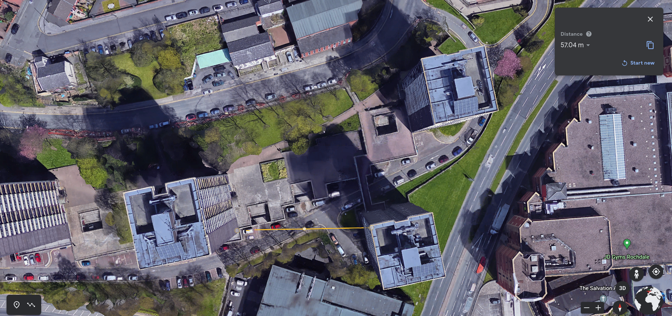Figure 2: Fig 2.

# Internet Access

There have been preliminary talks about internet service providers, management of that access, and physical location of the primary gateway.

The most logical and practical solution woud be a gateway on site, and by a managed access provider. This could be Virgin connecting upto the existing Rochdale Council Public Metropolitan Area Network. The access control lists, firewall rules, etc, are already in place and work well. RBH also use BT at The Strand Community Hub to manage accesss there. Also, the site is right next to BT’s main telephone exchange in the area. There is also the local and very reputable ISP (internet service provider) who could offer range of solutions.

It was also suggested that The Pioneers Museum might have capacity, and will, to provide access to their network. Although I doubt it will have the bandwidth at present to cope with the anticipated demand. (fig 3.) This would be upto negotiation with the team at The Pioneers Museum, and importantly comunicating the estimated volume of users that may be using it.

The closest other site that was suggested was The Rochdale Exchange Shopping Centre. At this stage we are unsure if there is any existing public wifi on this site.

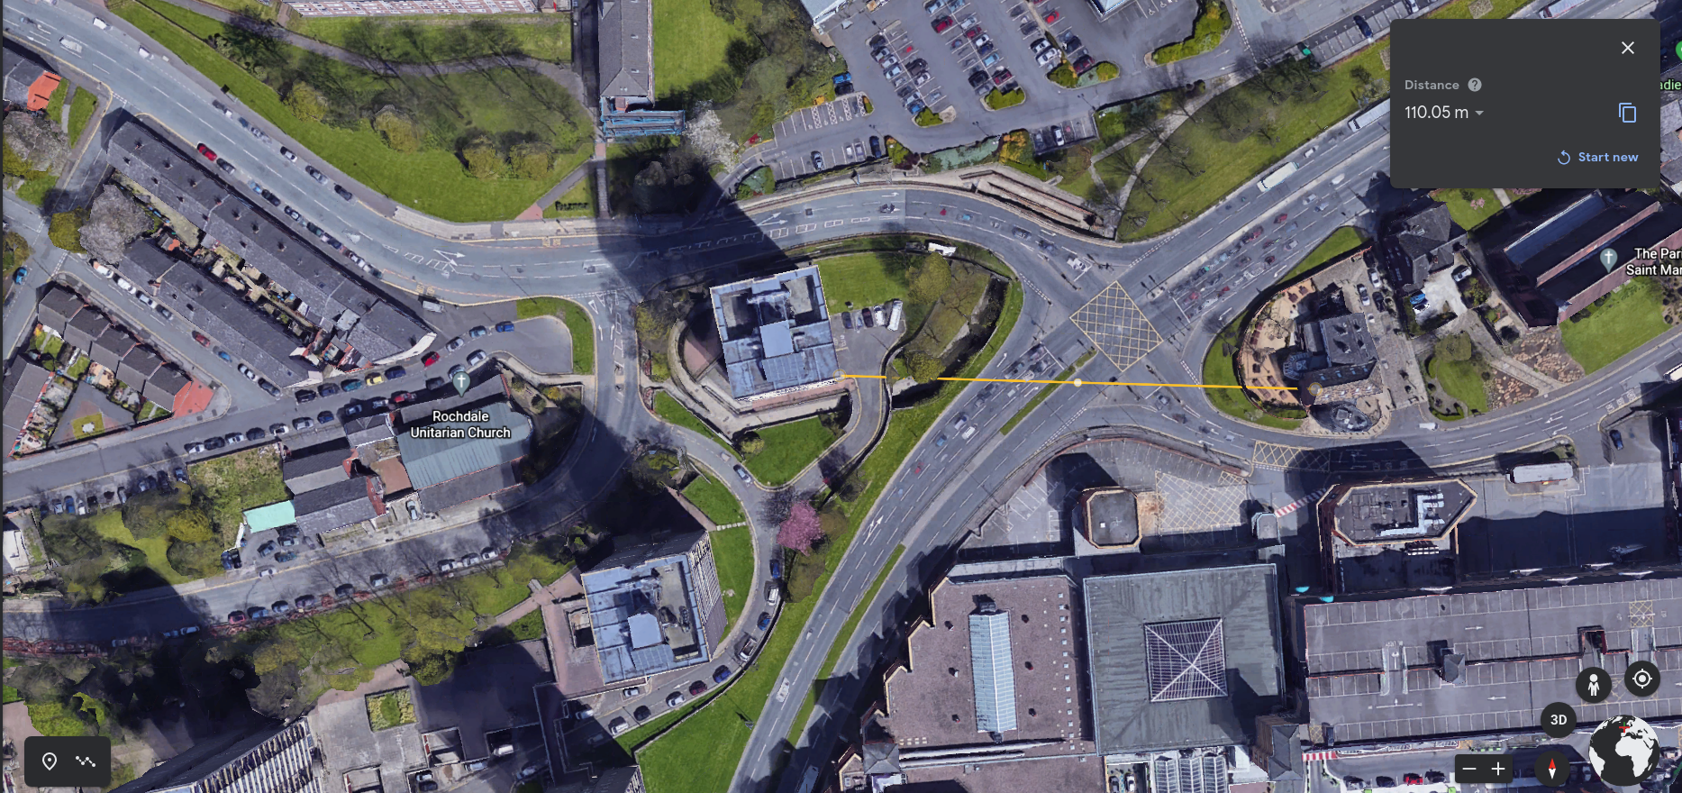Figure 3: Fig 3.

It was also suggested that maybe we could connect to Touchstones, or Rochdale Town Hall. Although these are possible, the distances would cause a significant reduction in internet speed and bandwidth. (fig 4.)

Given this information, our suggestion in an internet connection on site, with at least 1gb bandwidth.

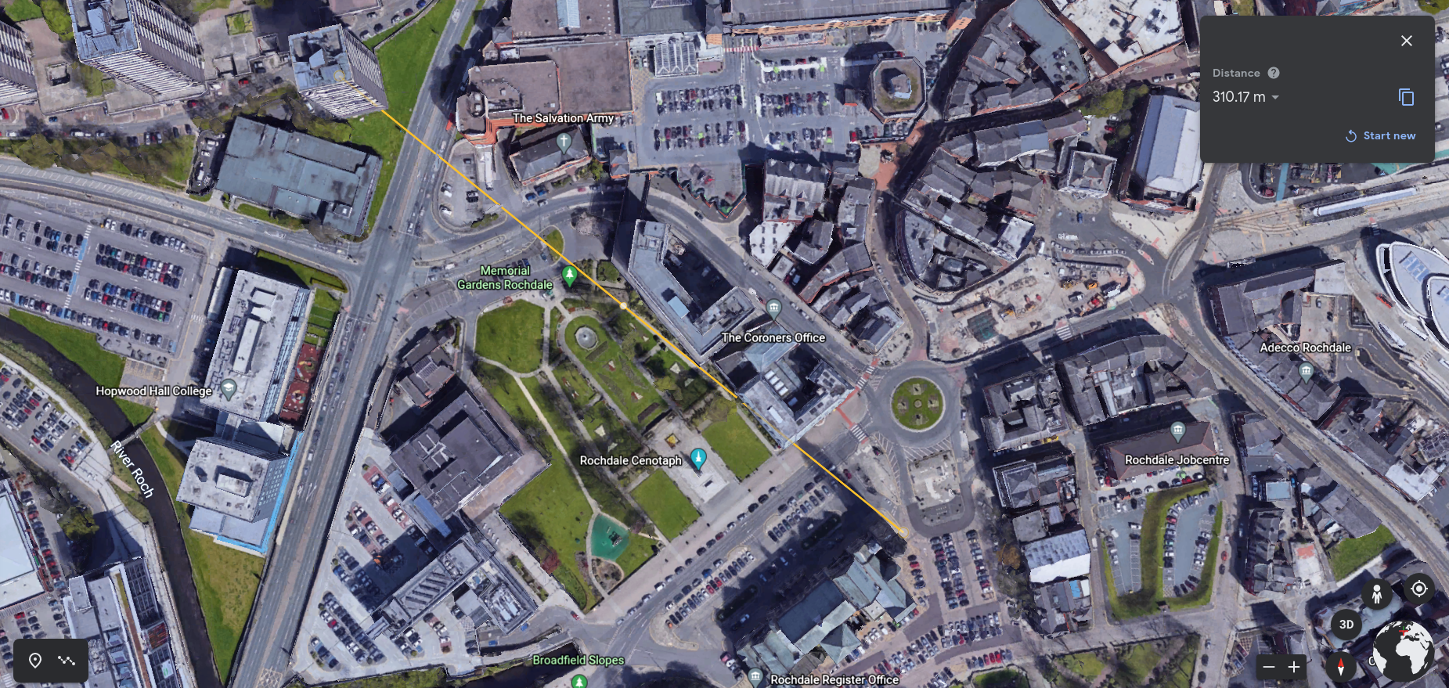Figure 4: Fig 4.

# Bridging Over To Lower Falinge

If/when the College Bank stage proves succesful, the gap is easy to bridge, with a directional antenna, between Mardyke and Pershore on Lower Falinge. Then we will repeat the process of rippling signal across the estate in the same way as at College Bank. (fig 5.)

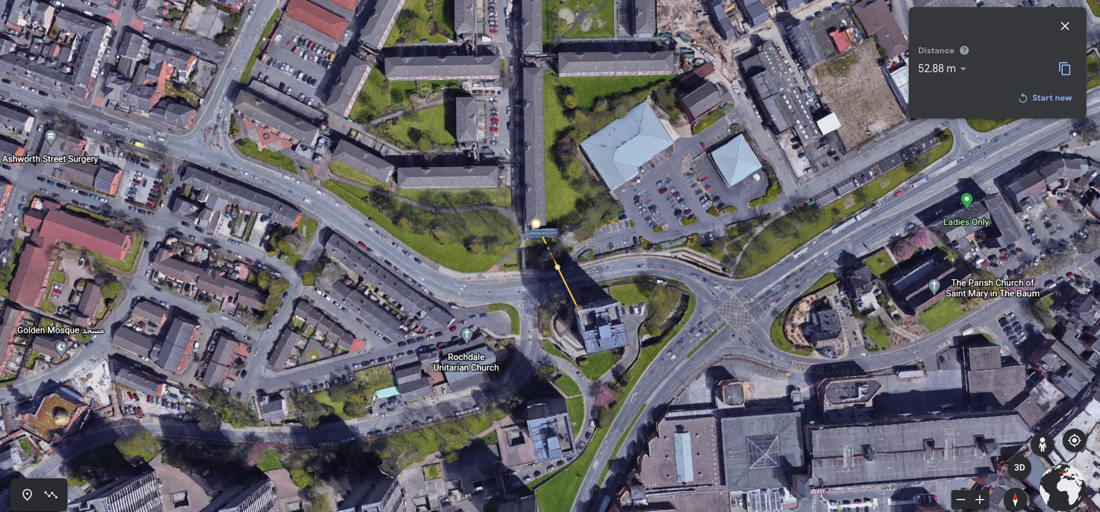Figure 5: Fig 5.

# Building The Topology With Routers, Access Points and Nodes.

**Line-of-Sight & Fresnel Zones**

An important requirement for achieving the highest possible performance in any outdoor

wireless link is keeping a clear line-of-sight. Line-of-sight refers to an elliptically-shaped

area between both ends of the radio link. This area divides into progressively larger zones,

called Fresnel zones. Within these zones, common obstructions like foliage, metal surfaces,

and even rainfall can result in scattered or reflected signals. With outdoor wireless, such

signals can cause multipath, which can negatively impact the receive signal.

Fresnel zones are measured according to the radius at a given distance. As illustrated,

Fresnel zones have a shape similar to an ellipsoid, where the radius is largest at the

center of the ellipsoid—exactly half the total link distance. Consider the following rules

concerning Fresnel zones:

As link distance increases, the radius also increases.

As the frequency of the radio link decreases, the radius also increases.

The less obstructions to the link, the better the performance.

60% of the first Fresnel zone must remain free to achieve a successful link.

Mount the antenna at a greater height to clear Fresnel zones

Keep in mind that Ubiquiti airLink software only considers terrain elevation (per

Google Earth) and not physical objects (ex. trees, buildings) that could obstruct the

Fresnel zones.

Ubiquiti Networks, Inc.

13

RF14

Theory

PtP Link with 1st Fresnel zone obstructed.

PtP Link with 1st Fresnel zone unobstructed, but likely

obstructed by ground objects due to low mount height.

PtP Link with 1st Fresnel zone unobstructed, and

mounted sufficiently high to avoid obstruction by objects.

Why HD WLANs Generally Fail?

Ubiquiti identifies three major areas that impact the performance of every HD WLAN

deployment:

Most Impactful Aspects of High Density Deployments

Problem Area

Broadcast/Multicast Domain Control

WLAN Planning & Design

Description

Uncontrolled network traffic jeopardizes

airtime, resulting in decreased speed,

increased latency, and potential

connectivity problems.

Inadequate and improper planning/design

physically inhibits wireless performance

and cripples user activity on the network.

Solution

Besides assigning VLANs to WLANs,

configure Port Isolation at the switch layer

to limit unnecessary traffic and conserve

precious airtime available to stations in the

HD WLAN.

Carefully anticipate and plan for network

capacity parallel to the user requirements

for the HD WLAN prior to methodically

designing the coverage area with proper

channel reuse patterns.

Site Survey, Analysis, & System

Characterization

Lackadaisical attention of the RF

environment results in careless placement

and inept configuration of APs for poor

wireless performance.

Before, during, and after deployment,

consciously track, measure, and evaluate

signals, noise, traffic, and other metrics to

optimize the HD WLAN accordingly.

Four Part HD WLAN Design Guide

This four-part guide presents and explains, from start-to-finish, the implementation of an

HD WLAN using the Ubiquiti UniFi platform:

Part 1 - Planning

Part 2 - Design

Part 3 - Deployment

Part 4 - Config

64

Ubiquiti Networks, Inc.

High-Density WLAN Design Guide

Part 1a - Planning - Application Requirements

The Purpose of the HD WLAN

Regardless of user density, the purpose of every WLAN is to support the wireless users’

application requirements. Therefore, the very first step when planning for the WLAN is

to understand the user applications and behavior. Typical projects involving HD WLANs

include stadiums, auditoriums, concerts, and other events where a high volume of users

gather across the coverage area. The most common applications for these HD scenarios

range from social media to live video/VoIP streams to simple web browsing. Consequently,

use of these applications may see varied levels of activity due to the nature of the event,

such as with spontaneous traffic bursts (e.g., everyone posts to social media during breaks)

or as more constant streams of data (e.g., students taking notes in a lecture hall).

Core Applications Define Planning & Design

Recognizing the core applications and types of users on the network, begin to plan and

design the HD WLAN with regards for the unique limitations and requirements of the

planned project. For example, the performance of latency-sensitive applications like VoIP

can degrade as WLAN usage reaches peak levels. Why? Because the wireless channel is

shared among all nearby, active stations; an 802.11 station (i.e., the VoIP user) must ‘wait’

to transmit until the channel is free of activity. Fundamentally speaking, the principal

applications and services on the network dictate the architecture and design of the

WLAN—especially in HD scenarios.

Realistic WLAN Planning/Design

Can a WLAN simultaneously support latency-sensitive applications, as well as high

bandwidth users? With total control over all of the variables affecting the WLAN, including

client devices and the physical environment for deployment, the realization of both

objectives in a single, culminating project becomes more realistic. When faced however

with “bring your own device” (BYOD) scenarios, as HD WLANs often are, limited control

over environmental variables often at time of planning forces the network to choose

between supporting high throughput or low latency applications.

Part 1b - Planning - User Bandwidth

Client Traffic Analysis via UniFi DPI

Following deployment, enterprise network administrators can take advantage of the Deep-

Packet Inspection (DPI) engine running on the UniFi Security Gateway (USG) to review

the applications in use by client devices on the network. The UniFi Controller summarizes

the total bandwidth consumed by the user applications, as well as the individual activity

of users, so WLAN administrators can make firewall and other configuration changes to

improve the performance of the network.

Ubiquiti Networks, Inc.

65

High-Density WLAN Design Guide

What is “Service Level Assurance”?

Prior to deployment however, anticipate which applications will be serviced by the HD

WLAN to develop a plan for “Service Level Assurance” (SLA) ahead of estimating the “Per-

Client Bandwidth”. A clearly-defined SLA identifies the primary applications and services to

be supported on the intended network (such as VoIP or YouTube), and therefore, guides

the early stages of planning and designing the WLAN architecture. Keep in mind that

although low-end VoIP and video calls require minimal bandwidth, their tolerance for

latency is also much lower, and therefore are designed uniquely. Although UniFi APs give

“Quality of Service” (QoS) priority to such traffic (per WMM standards), initial planning/

design for the HD WLAN should cater to the specific needs of the applications.

Create an SLA for the HD WLAN

To help formulate the SLA for the users on our unique HD WLAN, let’s reference the client

device “current-e58ba353” as a baseline example. A quick analysis of the DPI section under

the UniFi Client Properties tab reveals its top three applications to be:

1. Web Browsing

2. Social Media

3. Video Download

“Application Requirements” Data Table

The following “Application Requirements” table relates info about the speed and

connection required to service some of the most popular applications used in today’s

WLANs.

Application Requirements

Type

Example

Bandwidth (Mbps)

Latency Tolerance

Packet Flux

Email & Instant

Gmail, Messages

0.1

High

Bursty

Messenger

VoIP

Skype Audio Call

0.1

Low

Constant

Podcast/Radio

Pandora, Spotify

0.2

Medium

Bursty

Download

Social Media

Instagram, Facebook

0.25

High

Bursty

Video Call

Skype Video (Low)

0.3

Low

Constant

Skype Video (High)

0.5

Low

Skype Video (HD)

1.5

Low

Web Browsing

Wikipedia, Google

0.5

High

Bursty

Web Results

Reddit, Google Image

1

Results

Video Download

YouTube 240p

0.4

Medium

Bursty

YouTube 360p

0.75

YouTube 480p

1

YouTube 720p

2.5

YouTube 1080p

4.5

Online Gaming

League of Legends

2

Low

Constant

Internet TV

Netflix 720p

4

Low

Bursty

Netflix 1080p

5

File Sharing

Bittorrent

10

High

Bursty

File Backups

Dropbox

10

High

Bursty

66

Ubiquiti Networks, Inc.

High-Density WLAN Design Guide

SLA for Multitasking & Multiple Users Types

In some WLAN scenarios, the SLA may seek to support a variety of user types, or even

multiple applications per client device (i.e., network multitasking, background services),

and should therefore sum together the total Bandwidth required for each application.

“Application A Bandwidth + Application B Bandwidth + Application C Bandwidth + ... ”

“Per-Client Bandwidth”

For purposes of our HD WLAN example, our SLA assumes that the user (guest) is single-

tasking, and therefore, seeks to support the most bandwidth intensive application used by

client “current-e58ba353”: Video Download (0.3-4.5Mbps, with 1Mbps assumed for mobile

resolution playback). This means that the “Per-Client Bandwidth” (that is, the HD WLAN’s

SLA) is approximate 1Mbps.

“Maximum Aggregate Throughput Requirement”

To discover the “Maximum Aggregate Throughput Requirement,” that is, the total amount

of bandwidth needed for the HD WLAN to support ALL client devices simultaneously,

multiply the “Per-Client Bandwidth Requirement” (1Mbps) by the “Total Number of Client

Devices” (the “FedEx Forum” has a seating of 18,119). While not all 18,119 in attendance

will bring one mobile device to the event, planning for future growth is an important

consideration for every WLAN.

“Per-Client Bandwidth Requirement” x “Total Number of Client Devices”

= “Aggregate User Throughput Requirement”

(1Mbps) x 18,119 Clients

= 18,119Mbps Aggregate

“Expected Peak Aggregate Throughput”

Therefore, the “Maximum Aggregate Throughput” at the “FedEx Forum” is 18,119Mbps.

However, since it is impractical to assume that all 18,119 will ever pass traffic

simultaneously, let’s multiply the “Expected Peak Usage” (let’s estimate 50% of total

attendance) by the “Maximum Aggregate Throughput Requirement” to determine the

“Expected Aggregate Throughput”.

“Maximum Aggregate Throughput Requirement” x “Expected Peak Usage”

=“Expected Peak Aggregate Throughput”

(18,119Mbps) x (50%)

= 9059.5Mbps “Expected Peak Aggregate Throughput”

Later on, the “Expected Peak Aggregate Throughput” value will directly help to estimate

the minimum number of Access Points required for the HD WLAN deployment.

Upstream Data Links

The ~9Gbps of data passed on the HD WLAN by the guest users is Internet traffic, and

therefore, the upstream pipe to the ISP should support the “Expected Peak Aggregate

Throughput” to account for the offered SLA at the event. Throughout the HD WLAN,

make sure that upstream network infrastructure (e.g., switches) accommodates the traffic

bandwidth downstream (i.e., aggregation switches at core, access switches at edge).

Ubiquiti Networks, Inc.

67

High-Density WLAN Design Guide

Part 1c - Planning - WLAN Capacity

What is Capacity?

In the context of all WLANs, capacity is defined as the data rates supported by an AP and

its respective clients. Capacity is therefore, twofold dependent on the characteristics of

both client devices and APs (hereafter called “stations”). By anticipating and analyzing the

characteristics of stations, we can accurately calculate the capacity of the network in order

to estimate the total number of access points required to support the planned HD WLAN.

Choose the Best AP Possible

Although “bring your own device” (BYOD) scenarios mean client devices cannot be

consciously chosen, fortunately, WLAN administrators can select access points whose

wireless characteristics offer the best performance to match their particular HD WLAN

scenarios. This is also important to ensure that the HD WLAN has longevity through down-

the-road support for the client devices of today and tomorrow.

Introducing the UAP-AC-HD

The UAP-AC-HD is Ubiquiti’s premiere 4x4 MU-MIMO Access Point for HD WLAN

deployments. The UAP-AC-HD features the latest, cutting-edge 802.11 technology

for breakthrough speeds (2.5Gbps aggregate PHY rates) at a revolutionary price that

undercuts all competitors. The unbeatable price/performance advantage entices WLAN

administrators tasked with deploying HD-ready APs on a tight budget, since more APs

(beneficial in HD WLAN) can be deployed for a fraction of the price. And as Wave-2

802.11ac client devices begin to flood the consumer market, the UAP-AC-HD’s MU-MIMO

technology especially targets HD WLANs, inasmuch as its synchronous, multi-client data

streams push airtime efficiency to new levels in extremely dense coverage areas.

Introducing the UAP-AC-M

Alternatively, the UAP-AC-M unit supports versatile coverage options through external

connectors for pairing with directional antennas. For example, by pairing the UAP-AC-M

with a 45° airMAX sector antenna, WLAN administrators can produce small, controlled

5GHz cells—ideal in certain HD WLAN scenarios. By comparison, the omnidirectional

antennas and mounting capabilities make the UAP-AC-HD well-suited for low-ceiling and

wall deployments, while the UAP-AC-M (a Wave 1 “Single User” (SU) MIMO AP) is ideal for

high-vaulted ceilings seen in auditoriums, stadiums, and concert halls.

WLAN Capacity Variables

To review, there are five variables that determine the supported data rates of a WLAN,

including:

1.802.11 Protocol - the hardware standard characterizing the 802.11 stations on the

WLAN (a, b, g, n, ac Wave 1, ac Wave 2). As a backward-compatible AP, the UAP-AC-HD

immediately serves in HD deployments today, while anticipating growth as WLANs

scale to support more client devices for years to come.

68

Ubiquiti Networks, Inc.

High-Density WLAN Design Guide

2.3.4.5.Spatial Streams - the total number of data streams simultaneously transmitted

and received by the AP and clients. “Multiple In, Multiple Out” (MIMO) operation

traditionally has been limited by the supported data streams of the single client with

whom the AP communicates. As a Wave 2 802.11ac access point, the UAP-AC-HD

boosts the available airtime through true “Multi-User” MIMO mode, concurrently

pushing up to 8 streams of data to clusters of 2G & 5G clients. And since most client

devices opt for less antennas (i.e., fewer spatial streams) to conserve battery life, the

UAP-AC-HD’s MU-MIMO technology is critically important to ensuring maximum WLAN

performance.

Channel Width - the bandwidth over which an AP and its clients transmit data signals

(20/40/80 MHz). While 40/80 MHz channels are tempting, HD WLANs dictate use of 20

MHz channel widths to conserve the number of channels available for reuse during

deployment (especially true in extreme HD scenarios). In contrast, larger channel

widths in HD scenarios generally create a fundamentally flawed WLAN design where

closely-placed AP cells operating on same or nearby channels see degraded SNR

performance and increased contention for use of the wireless channel.

Signal-to-Noise Ratio (SNR) - the difference in receive signal (the desired data signal)

and noise (the combined level of in-band interference). From the point-of-view of

HD networks, SNR poses the greatest threat to performance since by nature, densely-

packed WLANs face greater interference. In order to ensure strong SNR levels for

clients, HD WLANs necessitate careful cell planning, including methodical channel

assignments, very low, controlled transmit power levels, and precisely deployed AP

locations.

Guard Intervals (GI) - 802.11n/ac WLANs support “long” and “short” waiting

periods between transmitted symbols (data). Although a short GI is desirable, UniFi

APs automatically toggle between “long” and “short” GI depending on the WLAN

performance.

PHY Rates vs. Throughput

Now that we have identified the factors that determine capacity, it’s important to

distinguish that these are physical-layer (PHY) data rates. What does this mean? Due to

overhead in the 802.11 protocol, the actual amount of real TCP data payload sent over

wireless signals is approximately half of the advertised PHY rates. When estimating the

capacity of the HD WLAN, we’ll factor a 50% reduction of the calculated PHY rates to align

with speed results experienced in the real-world.

Estimate Client Throughput

Returning to “current-e58ba353” as our baseline example, the reported 72.2Mbps PHY rate

assumes that a ‘typical’ client device is characterized as:

An 802.11n client device,

With a single (1x1) data stream,

Operating on a 20MHz channel,

With the best SNR,

And short GI.

Ubiquiti Networks, Inc.

69

High-Density WLAN Design Guide

By halving the PHY rate (72.2Mbps), we estimate that for the planned HD WLAN, the

“Achievable Real-World Client Throughput” is 36.1Mbps.

Estimate Minimum Required APs

By dividing the total “Aggregate User Throughput Requirement” (9059.5Mbps) by the

“Achievable Real-World Client Throughput” (36.1Mbps), we calculate 251 radios (rounded

up from 250.955679) as the minimum number of radios required to service the HD WLAN.

“Aggregate User Throughput Requirement” ÷ “Achievable Real-World Client Throughput”

= “Minimum Required Radios”

(9059.5Mbps) ÷ (36.1Mbps)

= 250.955679 Radios

In some scenarios, 2G and 5G bands can and should be used. Note however, that in many

HD WLANs, such as stadiums and arenas, only 5G channels are deployed since propagation

characteristics make 2G difficult to control.

Therefore, a “Minimum AP Estimate” of 251 APs could satisfy the capacity requirements for

the “FedEx Forum” site, based on the following assumptions:

Full person attendance at event is 18,119.

“User-to-Client Device” ratio is 1:1.

“Total Client Devices” at the event is 18,119.

“Expected Peak Usage” is 50%.

“Expected Peak Aggregate Throughput” is 9059.5Mbps.

‘Typical’ client device is 802.11n, 1x1, with strong SNR.

WLAN operates on 20 MHz channels with short Guard Intervals.

“Achievable Real-World Client Throughput” is 36.1Mbps.

Capacity Conclusions

The “Minimum AP Estimate” is a function of two capacity variables: “Aggregate User

Throughput Requirement” and “Achievable Real-World Client Throughput”. In simpler

words, a client’s speed and bandwidth requirements directly affect the capacity offered by

an AP. Increased client speeds (e.g., more spatial streams, improved SNR) means fewer APs

are required since each AP reaches greater capacity. Conversely, decreased client speeds

means more APs are required. As bandwidth consumption on the network increases, more

capacity is needed to support the user applications, thereby requiring more APs.

Theoretical vs. Actual APs Deployed

As a theoretical number, the “Minimum AP Estimate” gives network administrators a

starting point as they undertake the important task of designing the HD WLAN. The actual

number of APs deployed will depend on a broad range of physical factors noted during

site visits, floorplan analysis, as well as site surveys conducted at the intended HD WLAN

site.